12 WEEK ASSIGNMENT

WORD CLOUD

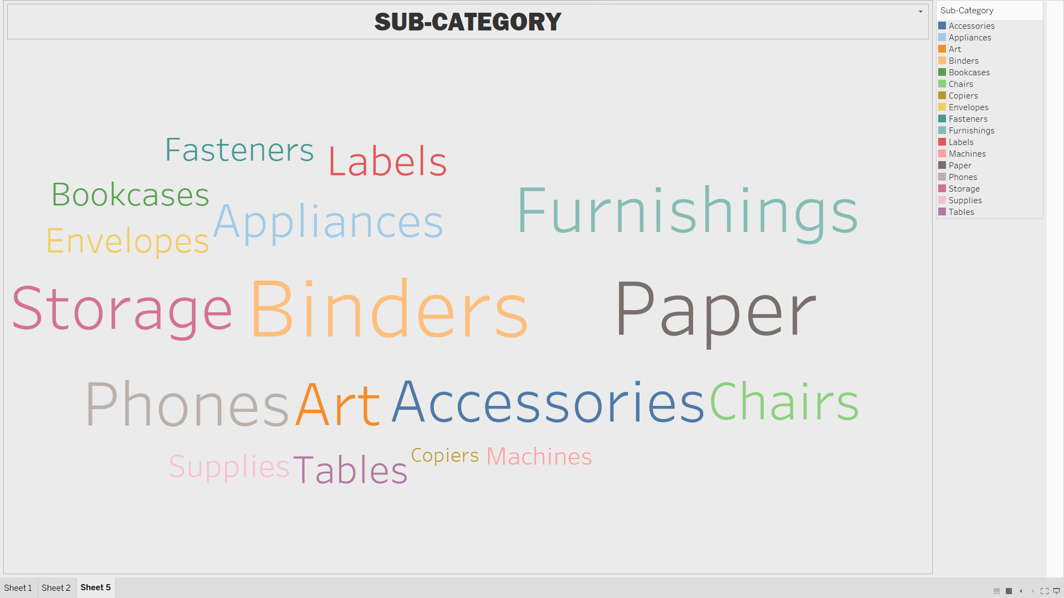

CONTROL CHART

